**Network Devices:** Network devices, also known as networking hardware, are physical devices that allow hardware on a computer network to communicate and interact with one another. For example Repeater, Hub, Bridge, Switch, Routers, Gateway, Brouter, and NIC, etc.

**1. Repeater** – A repeater operates at the physical layer. Its job is to regenerate the signal over the same network before the signal becomes too weak or corrupted to extend the length to which the signal can be transmitted over the same network. An important point to be noted about repeaters is that they do not amplify the signal. When the signal becomes weak, they copy it bit by bit and regenerate it at its star topology connectors connecting if original strength. It is a 2-port device.

**2. Hub** – A hub is a basically multi-port repeater. A hub connects multiple wires coming from different branches, for example, the connector in star topology which connects different stations. Hubs cannot filter data, so data packets are sent to all connected devices. In other words, the [collision domain](https://en.wikipedia.org/wiki/Collision_domain) of all hosts connected through Hub remains one. Also, they do not have the intelligence to find out the best path for data packets which leads to inefficiencies and wastage.

**Types of Hub**

* **Active Hub:-** These are the hubs that have their power supply and can clean, boost, and relay the signal along with the network. It serves both as a repeater as well as a wiring center. These are used to extend the maximum distance between nodes.
* **Passive Hub:-** These are the hubs that collect wiring from nodes and power supply from the active hub. These hubs relay signals onto the network without cleaning and boosting them and can’t be used to extend the distance between nodes.
* **Intelligent Hub:-** It works like an active hub and includes remote management capabilities. They also provide flexible data rates to network devices. It also enables an administrator to monitor the traffic passing through the hub and to configure each port in the hub.

**3. Bridge** – A bridge operates at the data link layer. A bridge is a repeater, which adds on the functionality of filtering content by reading the MAC addresses of the source and destination. It is also used for interconnecting two LANs working on the same protocol. It has a single input and single output port, thus making it a 2 port device.

**Types of Bridges**

* **Transparent Bridges:-** These are the bridge in which the stations are completely unaware of the bridge’s existence i.e. whether or not a bridge is added or deleted from the network, reconfiguration of the stations is unnecessary. These bridges make use of two processes i.e. bridge forwarding and bridge learning.
* **Source Routing Bridges:-** In these bridges, routing operation is performed by the source station and the frame specifies which route to follow. The host can discover the frame by sending a special frame called the discovery frame, which spreads through the entire network using all possible paths to the destination.

**4. Switch** – A switch is a multiport bridge with a buffer and a design that can boost its efficiency(a large number of ports imply less traffic) and performance. A switch is a data link layer device. The switch can perform error checking before forwarding data, which makes it very efficient as it does not forward packets that have errors and forward good packets selectively to the correct port only. In other words, the switch divides the collision domain of hosts, but the [broadcast domain](https://en.wikipedia.org/wiki/Broadcast_domain) remains the same.

**5. Routers** – A router is a device like a switch that routes data packets based on their IP addresses. The router is mainly a Network Layer device. Routers normally connect LANs and WANs and have a dynamically updating routing table based on which they make decisions on routing the data packets. The router divides the broadcast domains of hosts connected through it.

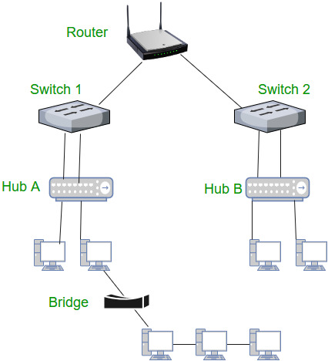

**6. Gateway** – A gateway, as the name suggests, is a passage to connect two networks that may work upon different networking models. They work as messenger agents that take data from one system, interpret it, and transfer it to another system. Gateways are also called protocol converters and can operate at any network layer. Gateways are generally more complex than switches or routers. A gateway is also called a protocol converter.

**7. Brouter** – It is also known as the bridging router is a device that combines features of both bridge and router. It can work either at the data link layer or a network layer. Working as a router, it is capable of routing packets across networks and working as the bridge, it is capable of filtering local area network traffic.

**8. NIC** – NIC or network interface card is a network adapter that is used to connect the computer to the network. It is installed in the computer to establish a LAN. It has a unique id that is written on the chip, and it has a connector to connect the cable to it. The cable acts as an interface between the computer and the router or modem. NIC card is a layer 2 device which means that it works on both the physical and data link layers of the network model.